A PROJECT OF PYTHON ON
STUDENTS MARKS MANAGEMENT

SUBMITTED BY
AJAY SHARMA
CLASS: XII-E

UNDER THE GUIDANCE OF
Mrs. Gurjinder Kaur(PGT)
COMPUTER SCIENCE

CERTIFICATE

This is to certify that AJAY SHARMA of class XII-E has prepared the report on the project entitled “STUDENTS MARKS MANAGEMENT”.

The report is the result of his efforts and endeavours. The report is found worthy of acceptance as final project report for the Computer Science of Class XII. He has prepared the report under my guidance.

Mrs. Gurjinder Kaur
PGT(Computer Science)
DEPARTMENT OF COMPUTER SCIENCE
K.V.P.V
ACKNOWLEDGEMENT

I would like to express a deep sense of thanks & gratitude to my project guide Mrs. Gurjinder Kaur ma’am for guiding me immensely through the course of project. She always evinced keen interest in my work. Her constructive advice & constant motivation has been responsible for the successful completion of this project. I also thank to my parents for their motivation and support. I must thank to my classmates as well. Last but not least; I would like to thank all those who had supported me directly and indirectly in any manner for completion of this project.

AJAY SHARMA
XII-E
ABOUT THE PROJECT

This project is designed to add a new student, update marks or details of existing student, delete details or to delete the whole table; it is also capable of searching a student’s details.

This project is made by SQL DBMS and Python connectivity using “mysql.connector” module. The module “sys” is used to provide access to some variables used or maintained by the interpreter and to functions that interact strongly with interpreter.

CODING

#STUDENTS MARKS MANAGEMENT
import mysql.connector as sql
import sys

#connect to mysql database
db=sql.connect(host="localhost",user="root",passwd="ajaysharma08",database="mysql")
cursor=db.cursor()
#check database is connected
if db.is_connected():
print("Database connected")

#MENU FOR STUDENT MARKS MANAGEMENT SYSTEM SOFTWARE
print("*************************************************")
print("WELCOME TO MY PROJECT STUDENT MARKS MANAGEMENT SYSTEM")
print("*************************************************")
print()
while(1):
print("1:TO CREATE TABLE FOR THE FIRST TIME")-Atharv
print(“1.1:Student management with result and fees”)-Hariom
print("2:TO DISPLAY TABLES OF DATABASE")
print("3:TO SHOW FIELDS OF TABLE")
print("4:TO DISPLAY ALL DATA")
print("5:TO ADD NEW STUDENT")-Atharv
print("6:TO SEARCH A STUDENT RECORD")-
print("7:TO CHANGE MARKS OF STUDENT")-Hariom
print("8:TO DELETE STUDENT ")
print("9:EXIT")
print()
ch=int(input("ENTER YOUR CHOICE"))
#Creating table for the first time
if ch==1:
try:
print(" Creating STUDENT table")
sql = "CREATE TABLE student(ROLL int(4) PRIMARY KEY,name varchar(15) NOT NULL,class char(3) NOT NULL,sec char(1),mark1 int(4),mark2 int(4),mark3 int(4),mark4 int(4),mark5 int(4),total int(4),per float(4));"
cursor.execute(sql)
mycon.commit()
except:
print("sorry some error occured")
#Displaying tables of database
if ch==2:
try:
cursor.execute("show tables")
for i in cursor:
print(i)
except:
print("sorry some error occured")
#Displaying Tables fields
if ch==3:
try:
table=input("enter table name")
cursor.execute("desc %s"%table)
for i in cursor:
print(i)
except:
print("sorry some error occured")
#Displaying all records of table
if ch==4:
try:
cursor.execute("select * from student")
data=cursor.fetchall()
print("ROLL NO","STUDENT NAME","CLASS","SECTION","SUBJECT1","SUBJECT2","SUBJECT3","SUBJECT4","SUBJECT5","TOTALMARKS","PERCENTAGE")
for i in data:
j=str(i).split()
for k in j:
print(k,end=" ")
print()
except:
print("SORRY SOME ERROR OCCURED")
#inserting new record into table
if ch==5:
r=int(input("Enter student roll number"))
name=input("ENTER STUDENT NAME")
c=input("ENTER CLASS OF STUDENT")
s=input("ENTER SECTION OF STUDENT")
m1=int(input("ENTER MARKS IN SUBJECT1"))
m2=int(input("ENTER MARKS IN SUBJECT2"))
m3=int(input("ENTER MARKS IN SUBJECT3"))
m4=int(input("ENTER MARKS IN SUBJECT4"))
m5=int(input("ENTER MARKS IN SUBJECT5"))
t=m1+m2+m3+m4+m5
per=t/5
query="insert into student values(%d,'%s','%s','%s',%d,%d,%d,%d,%d,%d,%d)"%(r,name,c,s,m1,m2,m3,m4,m5,t,per)
cursor.execute(query)
print("STUDENT RECORD SAVED IN TABLE")
db.commit()
#searching student details
if ch==6:
print("1:TO SERACH BY STUDENT ROLL NUMBER")
print("2:TO SEARCH BY STUDENT NAME")
c=int(input("ENTER YOUR CHOICE"))
#searching by student roll number
if c==1:
try:
roll=int(input("ENTER STUDENT ROLL NUMBER TO SEARCH"))
qry="select * from student where roll=%d"%roll
cursor.execute(qry)
data=cursor.fetchall()
if len(data)==0:
print("STUDENT NOT FOUND")
print("ROLL NO","STUDENT NAME","CLASS","SECTION","SUBJECT1","SUBJECT2","SUBJECT3","SUBJECT4","SUBJECT5","TOTALMARKS","PERCENTAGE")
for i in data:
j=str(i).split()
for k in j:
print(k,end=" ")
print()
except:
print("SORRY SOME ERROR OCCURED")

#searching by student name
if c==2:
try:
name=input("ENTER STUDENT NAME TO SEARCH")
qry="select * from student where name='%s'"%name
cursor.execute(qry)
data=cursor.fetchall()
if len(data)==0:
print("STUDENT NOT FOUND")
print("ROLL NO","STUDENT NAME","CLASS","SECTION","SUBJECT1","SUBJECT2","SUBJECT3","SUBJECT4","SUBJECT5","TOTALMARKS","PERCENTAGE")
for i in data:
j=str(i).split()
for k in j:
print(k,end=" ")
print()
except:
print("SORRY SOME ERROR OCCURED")

#TO update student marks
if ch==7:
try:
roll=int(input("ENTER ROLL NUMBER OF STUDENT WHOSE MARKS TO BE UPDATE"))
qry="select * from student where roll=%d"%roll
cursor.execute(qry)
data=cursor.fetchall()
if len(data)==0:
print("STUDENT NOT FOUND")
else:
m1=int(input("ENTER UPDATED MARKS IN SUBJECT1"))
m2=int(input("ENTER UPDATED MARKS IN SUBJECT2"))
m3=int(input("ENTER UPDATED MARKS IN SUBJECT3"))
m4=int(input("ENTER UPDATED MARKS IN SUBJECT4"))
m5=int(input("ENTER UPDATED MARKS IN SUBJECT5"))
t=m1+m2+m3+m4+m5
per=t/5
qry="update STUDENT SET mark1=%d,mark2=%d,mark3=%d,mark4=%d,mark5=%d,total=%d,per=%d where roll=%d"%(m1,m2,m3,m4,m5,t,per,roll)
cursor.execute(qry)
print("STUDENT RECORD UPDATED")
db.commit()
except:
print("SORRY SOME ERROR OCCURED")

# Delete student record from table
if ch==8:
try:
roll=int(input("ENTER STUDENT ROLL NUMBER ,YOU WANT TO DELETE"))
qry="select * from student where roll=%d"%roll
cursor.execute(qry)
data=cursor.fetchall()
if len(data)==0:
print("STUDENT NOT FOUND IN TABLE")
else:
qry="delete from student where roll=%d"%(roll)
cursor.execute(qry)
print("STUDENT RECORD DELETED FROM TABLE")
db.commit()
except:
print("SORRY SOME ERROR OCCURED")

#Exit from program
if ch==9:
sys.exit()

db.close()

OUTPUT

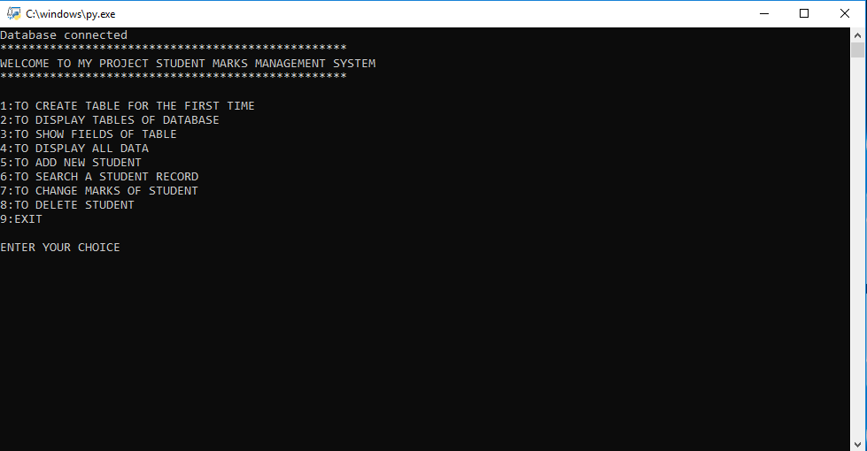

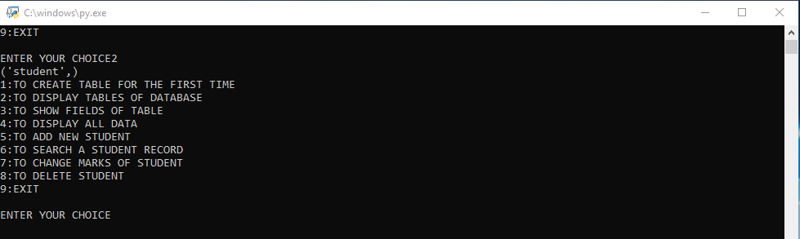

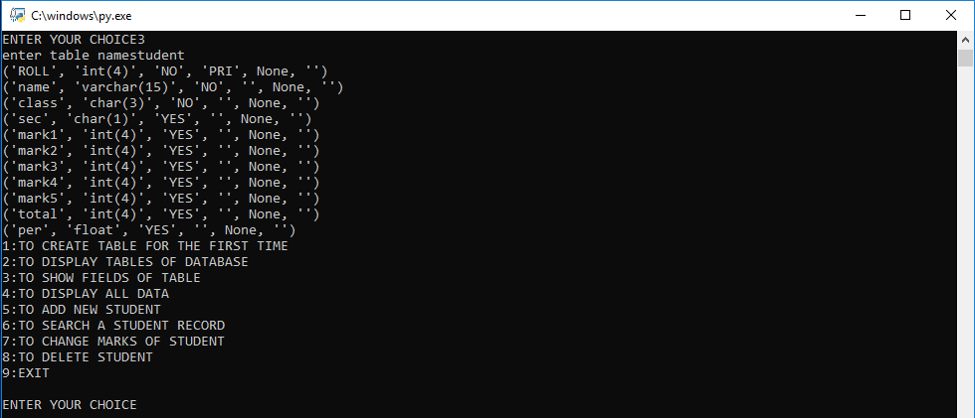

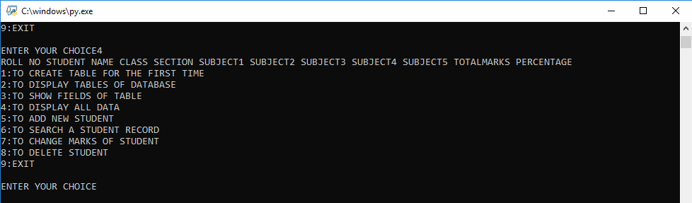

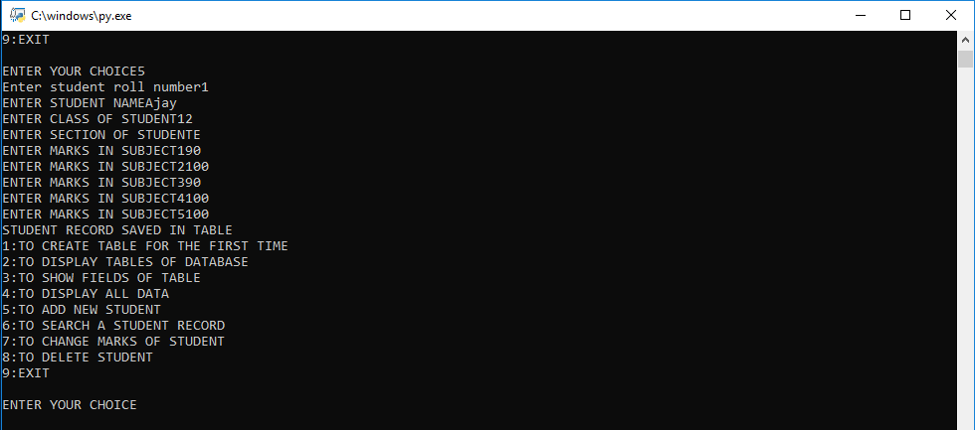

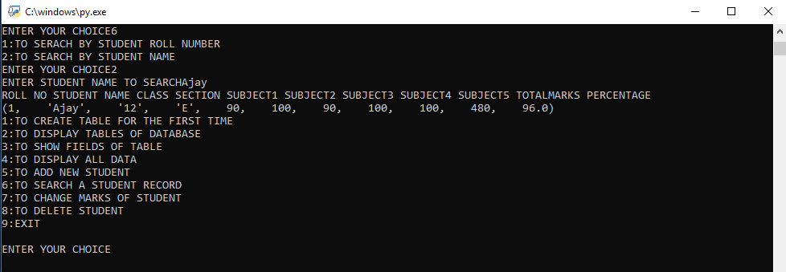

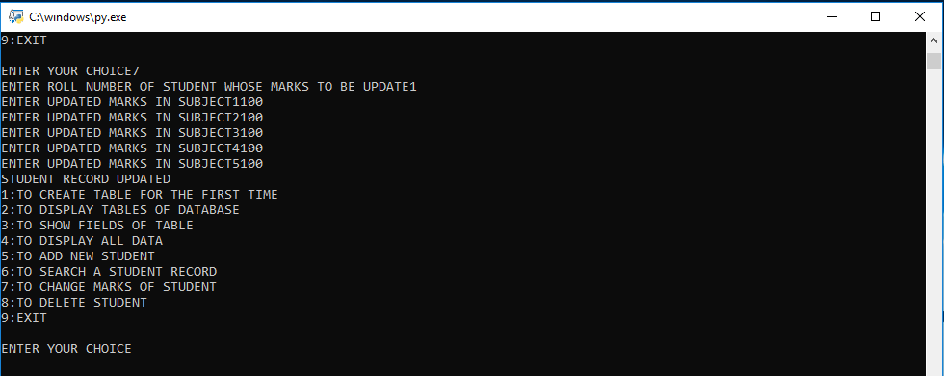

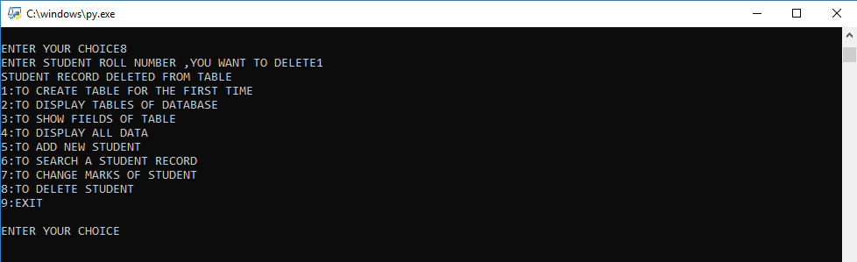

REFERENCE

- Computer Science with Sumita Arora
- Computer Science with Preeti Arora
- www.wikipedia.org

